Fully refurbished Retail Unit - **To Let**

Ground Floor & Basement, 58 Deansgate,

Bolton, BL1 1BG

2,727 sq ft (254 sq m)

• Town centre location

• Ready for immediate occupation

• In close proximity to the Market Place Shopping Centre

• High street retail with basement ancillary

­­

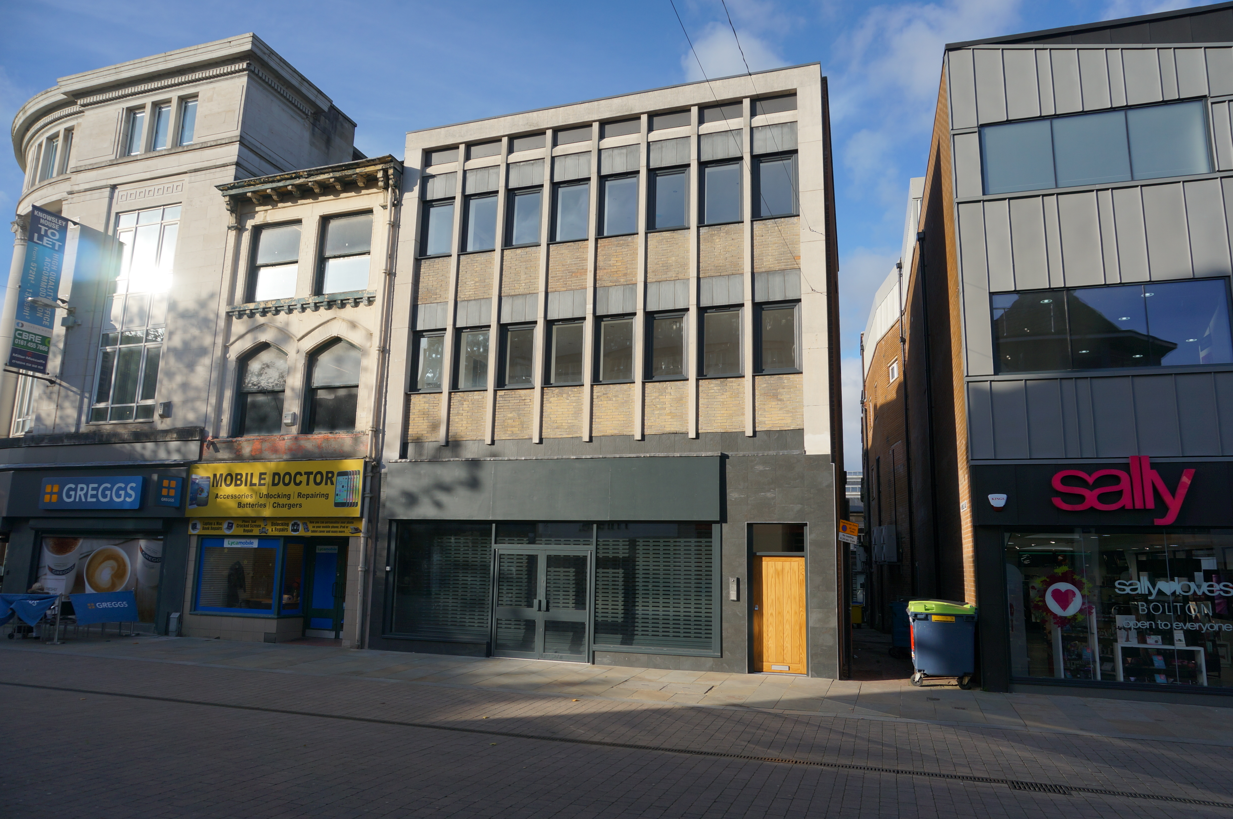

Planning Use

A1 Retail

EPC

A copy of the EPC is available on request.

VAT

VAT is applicable at the prevailing rate.

Business Rates

Interested parties should make their own enquiries with the Business Rates section of the Local Authority. Rateable Value : £60,000

Viewing

For viewing and further information please contact John Barker or Matt Kerrigan, Hitchcock Wright & Partners. Ref: JCB/MRK

Hitchcock Wright & Partners:

Tel. No. (0151) 227 3400

Fax. No. (0151) 227 3010

johnbarker@hwandp.co.uk

mattkerrigan@hwandp.co.uk

Subject to Contract

Description

The premises provides a refurbished shell ground floor retail unit with new shop front and roller shutter, within close proximity to local amenities and fully accessible from the pedestrianised high street which benefits from high footfall.

Below is additional ancillary space provided by the basement level.

Location

The premises are situated in a prime location on the pedestrianised section of Deansgate in close proximity to other occupiers including Marks & Spencer, Superdrug, Royal Bank of Scotland, Phones 4U, Santander, Caffé Nero, McDonalds and Market Place Shopping Centre, which is undergoing alterations to include restaurants and The Light Cinema.

Accommodation

The retail premises are arranged over the ground floor sales space (1,819 sq ft / 169 sq m) and basement ancillary (918 sq ft / 85 sq m).

Lease Terms

The premises are available by way of a new effectively full repairing and insuring lease.

Quoting rent £60,000 excl per annum

Misrepresentation Act 1967. Unfair Contract Terms Act 1977 The Property Misdescriptions Act 1991. These particulars are issued without any responsibility on the part of the agent and are not to be construed as containing any representation or fact upon which any person is entitled to rely. Neither the agent nor any person in their employ has any authority to make or give any representation or warranty whatsoever in relation to the property. Designed by 90degrees Design and Marketing 0161 833 1890. September 2015.